BLENDED INTENSIVE PROGRAMME ERASMUS+  LGBTI* in European laws and beyond  LYON 2026 | 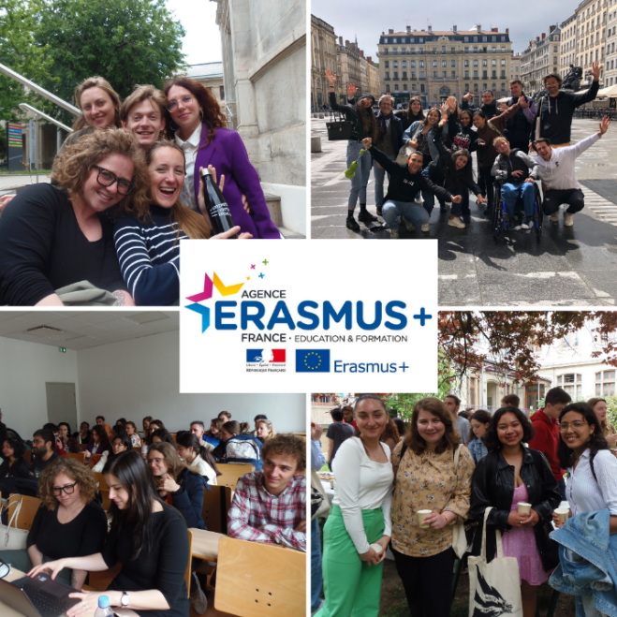

Blended Intensive Programmes Erasmus+ are hybrid programmes, consisting of an online part and an in-presence part. For this academic year, the week in attendance of the BIP LGBTI* in European laws and beyond will take place at the University Lumière Lyon 2 (France) from Monday 20 to Friday 24 April 2026.
The dates of the in-person and virtual sessions are fixed as stated above.
The programme details presented below may be slightly modified.

OBJECTIVES
- Learning more on the protection of SOGIESC (sexual orientation, gender identity and expression and sex characteristic) in international and national laws in Europe, with a focus on the European convention of human rights and the relevant case law;
- Learning more on the conceptual and pragmatical issues related to SOGIESC;
- Learning more on the evolution of the laws regarding SOGIESC: the legal forces and tools pushing for changes and the one resisting;
- Learning more on the diversity of legal approaches and the importance of the cultural context, through the comparative studies of international and internal laws.

ONLINE PROGRAMME
27th of February: 5PM-6PM (CEST / time of Paris) | Presentation of the program + methodological session on the expectation of the collective works later made by the students
23rd of March  5PM-7PM (CEST / time of Paris) | Presentation by the students of each national context related to SOGIESC + Q&A session on these contexts

Regarding the collective works, with slides and/or some notes that can be later shared with the other participants, it will be prepared by group of 4 to 5 students. There will be two collective works:
- One on the 27th of February, where students will have to make a presentation on the general situation of one (or all) of the groups marginalized because of their SOGIESC in their country. Can be addressed for instance the topic of the history of these minorities and the law applicable to them, their socio-economic situation nowadays and their social understanding by the rest of the society, the organization of civil society on this issue, the position of various political parties, their representation in the media and in art, etc.
- Another one on the 23rd of March, where students will have to make a presentation of a case, either national or international regarding the protection of human rights of LGBTI* people in their country. Students will try to answer these questions: what where the facts of the case? The procedure? The issue at stake? The legal answer? The opinion of lawyers or civil society? The various consequences of the decision?, etc.

LYON (campus Berges du Rhône – 4bis Rue de l'Université, 69007 Lyon)
Monday 20 – Friday 24 April 2026
IN-PRESENCE WEEK PROGRAMME
Monday 20th  Supervised by B. Moron-Puech (ULL2) | 9h00 – 9h30 | CLI.035 | Welcome breakfast - Registrations
Monday 20th  Supervised by B. Moron-Puech (ULL2) | 9h30 – 11h45 | CLI.035 | An historical approach of “LGBTI+” rights  Benjamin Moron-Puech (ULL2)
Monday 20th  Supervised by B. Moron-Puech (ULL2) | 11h45 – 12h30 | CLI.035 | Lunch offered
Monday 20th  Supervised by B. Moron-Puech (ULL2) | 12h30 – 15h30 | CLI.035 | Presentation & discussion of the students’ collective work  E. Mascarenhas (ULL2) & B. Moron-Puech
Monday 20th  Supervised by B. Moron-Puech (ULL2) | 15h45 – 16h45 | CLI.035 | The protection of “LGBTI+”’s body integrity in the European convention of human rights and other international laws–1  Benjamin Moron-Puech
Monday 20th  Supervised by B. Moron-Puech (ULL2) | 17h – 18h15 | CLI.035 | Suzanne Goldberg (Columbia university)  Law, Scapegoating, and the Targeting of Transgender People
Monday 20th  Supervised by B. Moron-Puech (ULL2) | 18h15 – 21h | Palais Hirsch – 1st floor | “BIP-nic”: a friendly gathering with participants from other BIPs (games to get to know each other and snacks provided)
Tuesday 21th  Supervised by B. Moron-Puech (ULL2) | 9h00 – 10h15 | CLI.035 | Connecting gender theory with law  Elena Mascarenhas
Tuesday 21th  Supervised by B. Moron-Puech (ULL2) | 10h30 – 12h30 | CLI.035 | 1 How to become a legal expert on SOGIESC?  2. The protection of “LGBTI+”’s body integrity-2  Lucas Ramon Mendos, (formerly with UN-OHCHR and ILGA World’s Research Manager)
Tuesday 21th  Supervised by B. Moron-Puech (ULL2) | 12h30 – 13h30 |  | Lunch (not offered)
Tuesday 21th  Supervised by B. Moron-Puech (ULL2) | 13h45 – 15h15 | CLI.035 | The right to respect for family life of “LGBTI+”, especially under the European convention of human rights  Peter Dunne (Bristol University)
Tuesday 21th  Supervised by B. Moron-Puech (ULL2) | 15h30 – 16h45 | CLI.035 | The right to gender identity in international human rights law, especially under the European convention of human rights  Benjamin Moron-Puech

Wednesday 22th  Supervised by Andreas Ziegler (UniL) | 9h15 - 10h45 - | CLI.035 | International economic treaties and their contribution to the protection of human Rights  Andreas Ziegler (University of Lausanne)
Wednesday 22th  Supervised by Andreas Ziegler (UniL) | 11h00 – 12h30 | CLI.035 | The protection against discrimination on the basis of SOGIESC  Marcin Górski (University of Lodz)
Wednesday 22th  Supervised by Andreas Ziegler (UniL) | 12h30 – 14h00 |  | Lunch (not offered)
Wednesday 22th  Supervised by Andreas Ziegler (UniL) | 14h – 17h00 | CLI.035 | T* vs the others oppressed groups?: discussing the potential conflict of rights.  Students’ discussion moderated by Benjamin Moron-Puech (ULL2) & Robert Wintemute (King’s College)
Wednesday 22th  Supervised by Andreas Ziegler (UniL) | 17h30 – 20h00 | Grand amphi (BDR) | Play by Martin Lewton, Mirando The Gay Tempest (W. Shakespeare - adapted)
Thursday 23th  Supervised by Andreas Ziegler (UniL) | 9h – 10h30 | CLI.035 | The assessment of SOGIESC asylum claims  Elias Tissandier (Leyden University)
Thursday 23th  Supervised by Andreas Ziegler (UniL) | 10h45 – 12h15 | CLI.035 | A conversation on the legal and philosophical foundation of LGBTIQ human rights  Damir Banovic (University of Sarajevo)
Thursday 23th  Supervised by Andreas Ziegler (UniL) | 12h15 – 13h15 |  | Lunch (not offered)
Thursday 23th  Supervised by Andreas Ziegler (UniL) | 13h15 – 14h45 | CLI.035 | The future of SOGIESC? Strategic reflections  Benjamin Moron-Puech (ULL2) & Etienne Deshoulières (Attorney of LGBT NGO) [TBC]
Thursday 23th  Supervised by Andreas Ziegler (UniL) | 15h30 – 17h00 | Meeting point: Place. de la Croix-Rousse, 69004 Lyon | Thematic guided tour: “Street-art of Croix-Rousse”

Friday 24th  Supervised by Benjamin Moron-Puech (ULL2) | 11h30 –  12h10 | CLI.035 | EXAM
Friday 24th  Supervised by Benjamin Moron-Puech (ULL2) | 12h10 –  13h30 | CLI.035 | Lunch offered
Friday 24th  Supervised by Benjamin Moron-Puech (ULL2) | 13h30 –  16h00 | AMPHI SAY | Sports and the inclusion of LGBTI*  Closing session with the participation of:  - Clément Durez (ULL2) & Pierre Michel (ULL2)  - Francine Raveney, (Council of Europe's Enlarged Partial Agreement on Sport)  - Daniel Rietiker (European Court of Human Rights)  - Lucie Tico & Karl Drapied (French University Sports Federation)

